PROMO 01

Unique registration Link: <https://us02web.zoom.us/webinar/register/3017600069298/WN_-bb4V-pjTT6XBkNfbpBX2w>

—--------------------------------------------------------------------------✨ Panel Alert! ✨  
📅 October 13, 2025 | ⏰ 8:00–9:00 PM EST | 💻 Live on Zoom + LinkedIn & Facebook

Let's speak about Veterinary Financial Health Panel *Hidden Profit Leaks: What Every Practice Owner Needs to Know About Money Management*

We’ll be covering:  
💡 Common overlooked expenses that quietly drain profits  
 📦 The power of inventory management in maintaining financial stability  
 💰 How to price your services to reflect their true value  
 📊 Using financial reports to guide better decision-making  
 ⚙️ And how small operational tweaks can create lasting profitability

🎟 Complimentary registration 👉 <https://us02web.zoom.us/webinar/register/3017600069298/WN_-bb4V-pjTT6XBkNfbpBX2w>

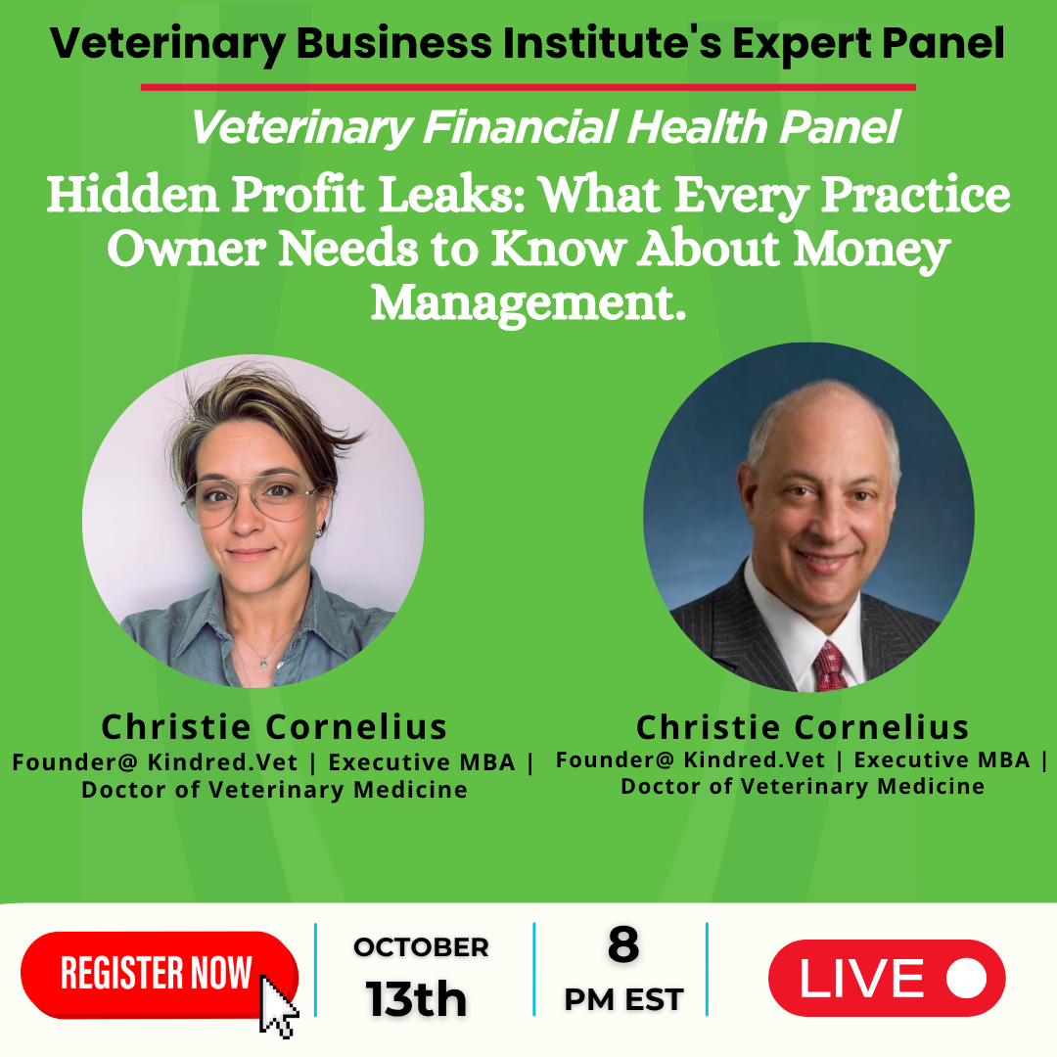

PROMO 02

Unique registration Link: <https://us02web.zoom.us/webinar/register/3017600069298/WN_-bb4V-pjTT6XBkNfbpBX2w>

—--------------------------------------------------------------------------✨ Panel Alert! ✨  
📅 October 13, 2025 | ⏰ 8:00–9:00 PM EST | 💻 Live on Zoom + LinkedIn & Facebook

I am very excited to speak at the Veterinary Financial Health Panel *Hidden Profit Leaks: What Every Practice Owner Needs to Know About Money Management*

We’ll be covering:  
💡 Common overlooked expenses that quietly drain profits  
 📦 The power of inventory management in maintaining financial stability  
 💰 How to price your services to reflect their true value  
 📊 Using financial reports to guide better decision-making  
 ⚙️ And how small operational tweaks can create lasting profitability

🎟 Complimentary registration 👉

<https://us02web.zoom.us/webinar/register/3017600069298/WN_-bb4V-pjTT6XBkNfbpBX2w>

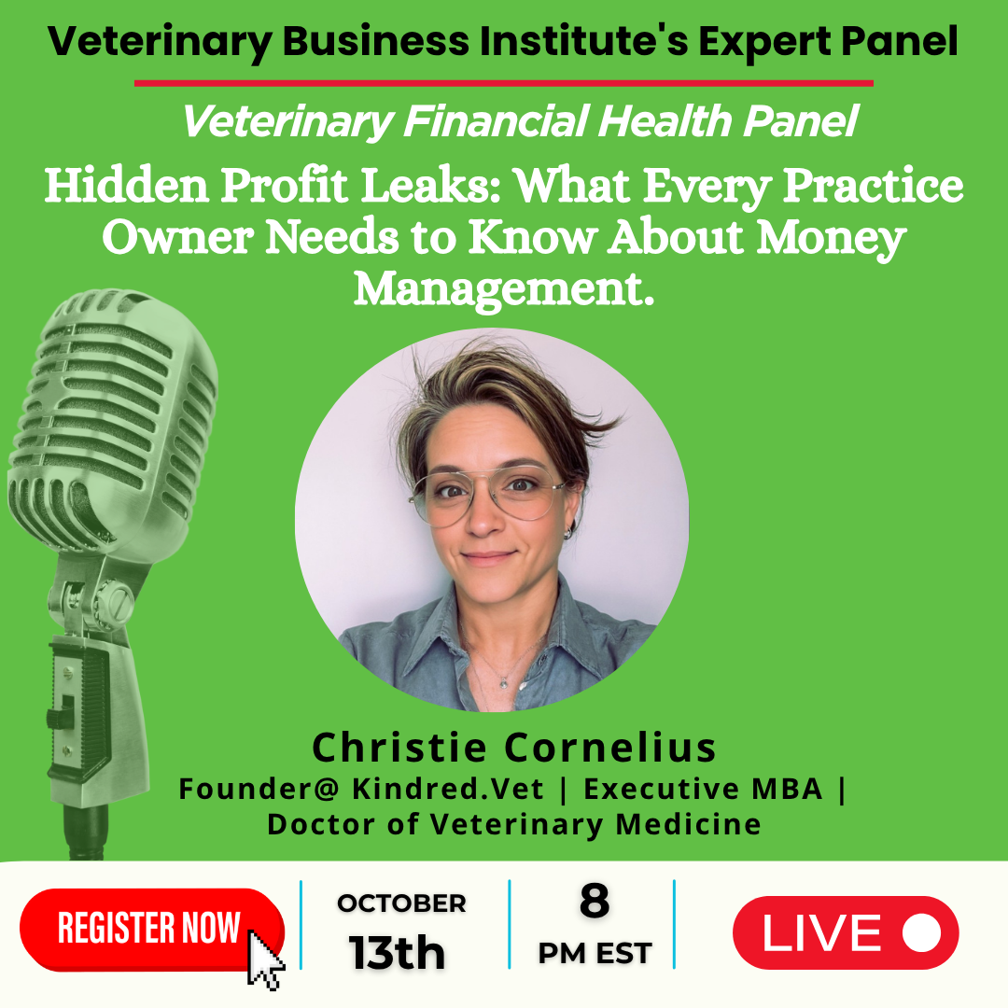

PROMO 03

Unique registration Link: <https://us02web.zoom.us/webinar/register/3017600069298/WN_-bb4V-pjTT6XBkNfbpBX2w>

—--------------------------------------------------------------------------✨ Panel Alert! ✨WE ARE LIVE TODAY✨  
📅 October 13, 2025 | ⏰ 8:00–9:00 PM EST | 💻 Live on Zoom + LinkedIn & Facebook

I am very excited to speak at the Veterinary Financial Health Panel, *Hidden Profit Leaks: What Every Practice Owner Needs to Know About Money Management*

We’ll be covering:  
💡 Common overlooked expenses that quietly drain profits  
 📦 The power of inventory management in maintaining financial stability  
 💰 How to price your services to reflect their true value  
 📊 Using financial reports to guide better decision-making  
 ⚙️ And how small operational tweaks can create lasting profitability

🎟 Complimentary registration 👉

<https://us02web.zoom.us/webinar/register/3017600069298/WN_-bb4V-pjTT6XBkNfbpBX2w>



Tab 4